
National 11-a-side Football Trials
Date: Sunday, 01 February 2015
Venue: King James School, Knaresborough, HG5 8EB
Time: 10:45am to 14:30pm (to arrive by 10:30am)

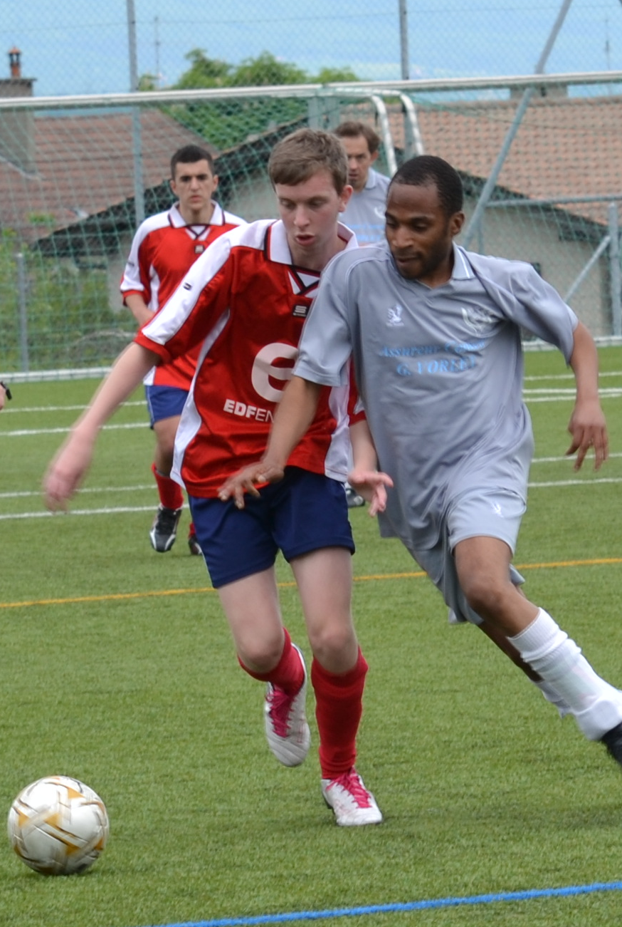
The National Mencap football trials will be held at King James School, King James Road, Knaresborough, on Sunday, 01 February 2015.

Itinerary

10:30 Registration

10:50 Welcome/Introductions

11:00 Group Training sessions

12:20 Short Break

12:30 11-a-side matches

14:00 Lunch (please bring packed lunches)

14:15 Selection/Announcement

14:30 Depart

Switzerland
Fifteen players will be selected to represent Mencap in Switzerland for a European football tournament. The squad will fly to Geneva on Thursday 21 May 2015 and return on Monday 25 May 2015

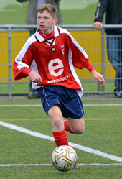
Training Weekend
There will also be a weekend training weekend in Wales on 01- 03 May 2015 to prepare the squad for the event. Further details of the weekend will be given to players selected on the day at Warwick.

Cost of the Geneva trip and training weekend
The expected cost to players will be £295 which covers the cost of the training weekend flights, accommodation and travel while in Geneva. Players selected should be prepared to pay a non-refundable deposit of £100 and be able to confirm their place within fourteen days of the trials date (15 Feb).

Nominations
Clubs may nominate up to 6 players to participate at the trials

All nominations must be made through a club Coach/Leader and must meet ALL of the criteria listed below. Nominations must be received before the closing date and made using the attached form. All sections of the form must be completed in full

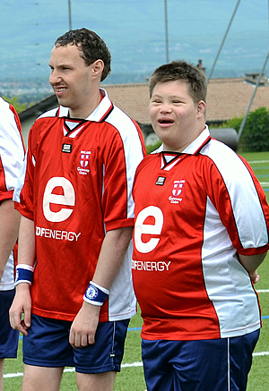
There is a charge of £5 per person to help cover the cost of holding the trials. Cheques should be made payable to Harrogate Mencap

A maximum of 65 places are available at the trials. These will be offered on a first come first serve basis.

Eligibility
- Players must be a member of Mencap or belong to a Mencap affiliated group
- Players must have a learning disability.
- Players must be male and over 18 years of age.
- Players must receive at least 20 weeks football training per year and play regular competitive football.
- Players should participate at Championship or League One level (FA Ability Counts).

Ability Level
Each year we try to rotate the ability level of the team chosen. This year the level of the team will be predominantly Intermediate & Lower Novice level. This level is equivalent to the (FA Ability Counts Championship & League One levels). Please bear this in mind when you are submitting your nomination(s). If players normally perform above or below this level, then you are not likely to be selected at the trials. Additional eligibility criteria is shown above;

Closing Date
The closing date for nominations is 24 January 2015. After this date, any spare places will be offered to groups/teams that have already nominated.

Submitting your form
Nominations forms should be submitted to the address below, together with payment.
Forms will be accepted by email, but cheques must still be received before the closing date.

Mark Summers
Mencap National Football Team Manager
1 Princess Drive
Knaresborough
N Yorks
HG5 0AG

Confirmation
Once your nomination form has been received, you will be sent confirmation regarding your attendance at the trials. You will also be sent the details of the venue, including facilities, where to meet, directions and maps. This will be sent to the contact email address that you have provided. If you require this info by post, please send a stamped addressed envelope.

Selection At The Trials
Players will be told if they have been selected for the team on the day. They will be given an information pack about the training weekend and the Geneva event. The pack will include a number of forms which need to be completed and returned within the week. This information will be emailed to the ‘contact for correspondence’ that you have given on the nomination form. .

About the National Football Team
The Mencap National Football team was formed over 30 year ago following its invitation to take part in a European championships held in Switzerland. Mencap have taken part in the championships every year since then.

In 2011, responsibility for the National football team passed to Harrogate Mencap, with the day to day management of the team being conducted by experienced coaches from various clubs around the country. This was to ensure that Mencap members were able to continue playing football for their country for many more years to come.

More details of the Mencap Football Team can be found at www.harrogategatewayfc.com

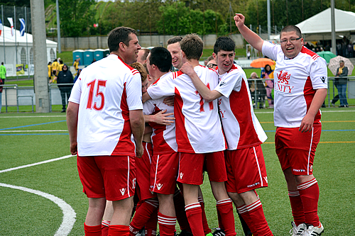
Contact: Mark Summers (Team Manager)
Tel: 07940 509757
Email: marksummers@btinternet.com

Summary of Dates
24 Jan 2015 Closing date for nominations
01 Feb 2015 Football Trials - Knaresborough
15 Feb 2015 Deposit of £100 due
24 Apr 2015 Balance of £195 due
01-03 May 2015 Squad Training Weekend
21-25 May 2015 Geneva Tournament

